Environmental Literacy Carbon Assessment:
--- High School Level, Form B ---

Science is easier to understand if you can make connections between what you know now and the new ideas that you are studying. This is a test that will help us understand what you know now. Please answer these questions as carefully and completely as you can. If you are not sure of the answer, please write about any ideas that you have. If you can help us to understand how you think about these questions, then we can do a better job of explaining science in ways that make sense to you.

Please put your initials (not your full name) in the boxes
Date ________________ | First | Middle | Last

Class ____________________________ Teacher _______________________

1. An apple is eaten by a boy and digested in his body.

a. What happens to the apple when it is digested?

b. Do you think the apple the boy ate can help all parts of his body (like his fingers) to grow?

Please circle one: YES NO

If you answered YES, please explain how can an apple that goes to the boy’s stomach help his fingers to grow. If you answered NO, please explain how the boy’s body makes his fingers grow.

2. When a baby was five months old, she weighed 15 lb. After 7 years, the baby has grown into a big girl, weighing 50 lb.
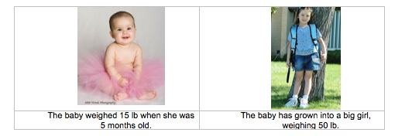

Do you think the baby girl will need any of the following things to grow and gain weight? Please circle Yes or No and explain your choice.

Things | Does the girl need it to grow? | If you circled yes, explain how the girl’s body uses it. What happens to it inside the inside the girl’s body?
Sunlight | Yes No
Water | Yes No
Air | Yes No
Food | Yes No

3. Gasoline is mostly a mixture of hydrocarbons such as octane: C₈H₁₈. Decide and circle whether each of the following statements is true (T) or false (F) about what happens to the atoms in a molecule of octane when it burns inside a car.

T F Some of the atoms in the octane are incorporated into carbon dioxide in the air.
T F Some of the atoms in the octane are incorporated into air pollutants such as ozone or nitric oxide.
T F Some of the atoms in the octane are converted into energy that moves the car.
T F Some of the atoms in the octane are burned up and disappear.
T F Some of the atoms in the octane are converted into heat.
T F Some of the atoms in the octane are incorporated into water vapor in the atmosphere.

a. When the gas tank is empty and the car stops, where is the energy that was in the gasoline?

b. What was the original source of energy of gasoline?

c. Is air needed for the car to use the gasoline? If so, how does the air change as the car runs?

4. Use the table below to explain where you think that carbon is found inside a person’s body and how it gets there.

Location |  | If you circled yes, explain how the carbon gets to that location. Include molecules in your explanation if you can.
Do people have carbon in their muscles? | Yes No
Do people have carbon in their fat? | Yes No
Do people have carbon in their blood? | Yes No

5. Which gas(es) do plants take in from their environments? (you may circle more than one)

Oxygen Carbon dioxide Other:_____________

Explain what happens to the gases once they are inside the plant.

6. People need energy to live and grow. Which of the following is/are energy source(s) for people? Circle Yes or No for each of the following and explain your answers.

- Water YES NO
- Food YES NO
- Nutrients YES NO
- Exercise YES NO
- Sunlight YES NO
- Oxygen YES NO

Please explain ALL your answers. What is the difference between the things that are energy sources and the things that are not energy sources?

7. When a person loses weight, what happens to some of the fat in the person’s body? Choose ONE answer that you think is best.
a. The fat is broken down and leaves the person’s body as water and gas.
b. The fat is converted into energy.
c. The fat is used up and disappears.
d. The fat is broken down and leaves the person’s body as feces and urine.

Please explain why you think that the answer you chose is better than the others. (If you think some of the other answers are also partially right, please explain that, too.)
8. When a match burns, the released energy
a. comes mainly from the match.
b. comes mainly from the air.
c. is created by the fire.
d. comes from the energy that you used to strike the match.
e. none of the above.

- Please explain your answer.

- What materials is the wood in the match made of, and where do these materials come from? Explain in terms of molecules if you can.

- As the match burns, it gets shorter in length and lighter. What happens to the materials the match is made of as the match burns?

9. A burning candle is put into an air-tight container. After some time, the candle stops burning.

a. Predict whether the air inside the candle will have more, the same, or less of the gases below. Explain where the gases come from or go to.
Gas | Prediction  (circle) | Explanation: How did burning the candle produce or use the gas?
Oxygen | More Same Less
Carbon dioxide | More Same Less
Water vapor | More Same Less

b. Where does the energy for burning come from? Please explain your answer.

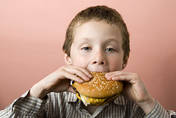 | 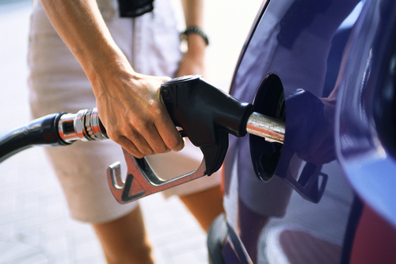 | 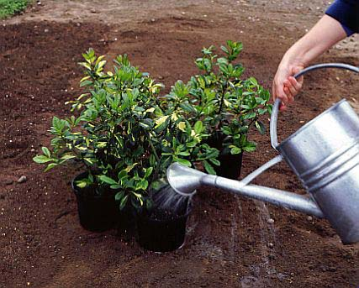
A. Eating a hamburger | B. Filling up a car with gasoline | C. Watering plants

10. The pictures above show three things happening.
A science teacher says that pictures “A” and “B” are similar events, but picture “C” is different from “A” and “B”. What reason do you think the science teacher might have for saying that? Explain as much as you can.

11. Grandma Johnson had very sentimental feelings toward Johnson Canyon, Utah, where she and her late husband had honeymooned long ago. Because of these feelings, when she died she requested to be buried under a creosote bush in the canyon. Describe below the path of a carbon atom from Grandma Johnson’s remains, to inside the leg muscle of a coyote. NOTE: The coyote does not dig up and consume any part of Grandma Johnson’s remains.

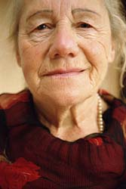 | 

